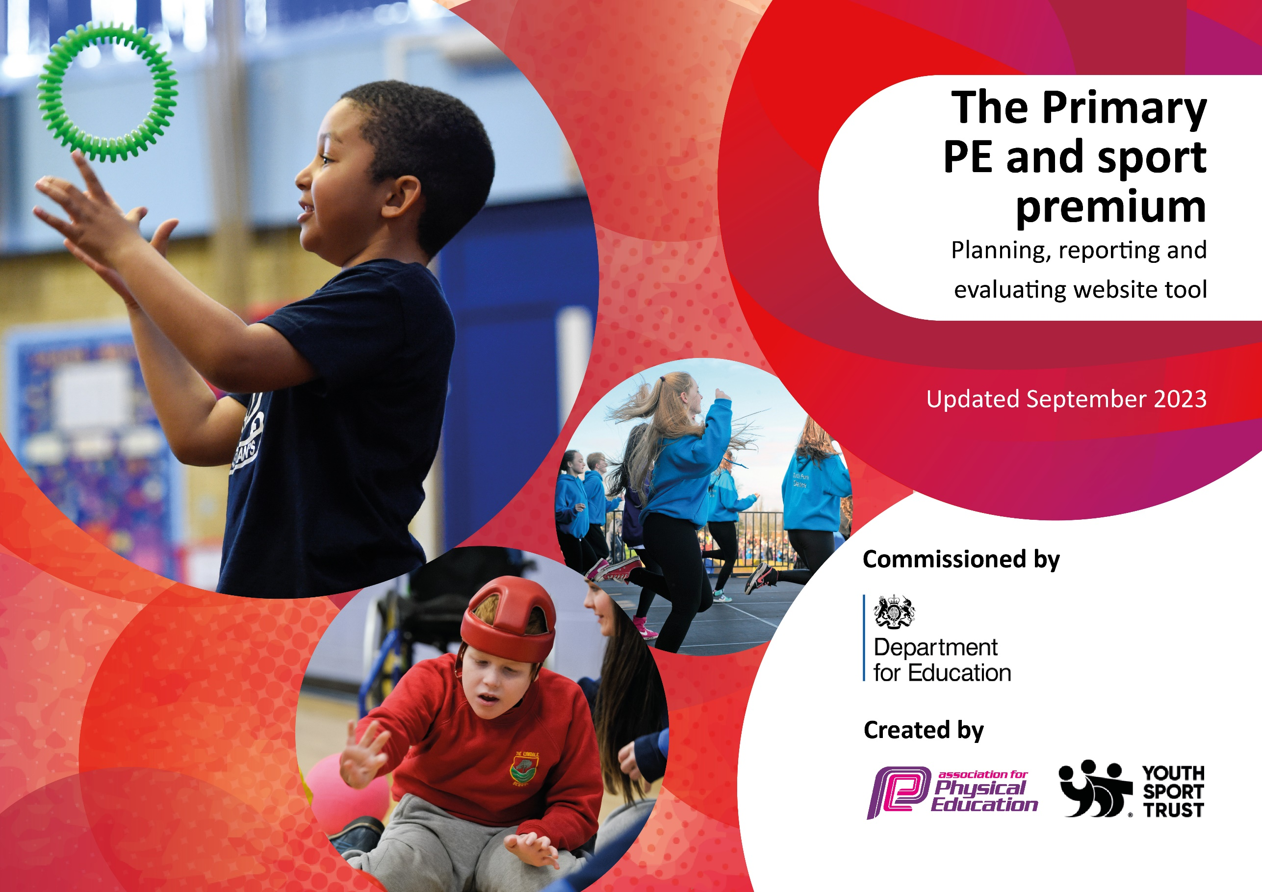

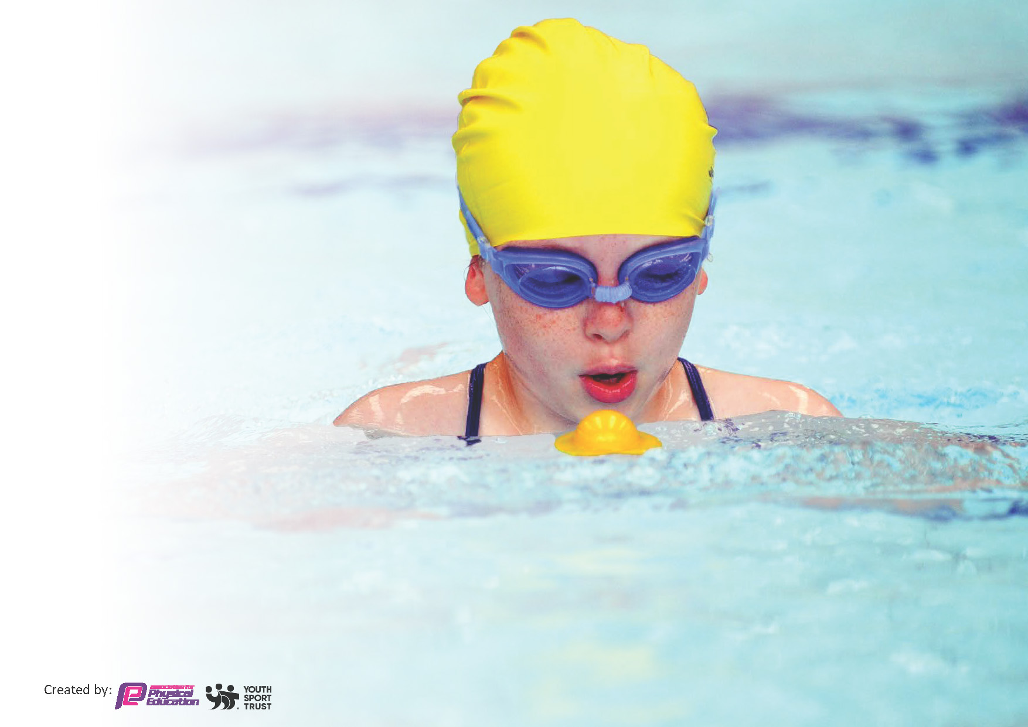
This template can be used for multiple purposes:
by:
- It enables schools to effectively plan their use of the Primary PE and sport premium
- It helps schools to meet the requirements (as set out in guidance) to publish information on their Primary PE and sport premium
- It will be an effective document to support Ofsted inspections enabling schools to evidence progress in Physical Education (PE) and evidence swimming attainment, which forms part of the PE National Curriculum. We would recommend schools consider
the Intent, Implementation and Impact of any spend, as examined within the Education Inspection Framework.

It is important that your grant is used effectively and based on school need.

Schools must use the funding to make additional and sustainable
improvements to the quality of the PE, School Sport and Physical Activity (PESSPA)
they offer. This means that you should use the Primary PE and sport premium to:

- Build capacity and capability within the school to ensure that improvements made now will benefit pupils joining the school in future years
- Develop or add to the PESSPA activities that your school already offers.

The Primary PE and sport premium should not be used to fund capital spend projects; the school’s core budget should fund these. Further detail on capital expenditure can be found in the updated Primary PE and sport premium guidance.

The Primary PE and sport premium guidance, outlines 5 key priorities that funding should be used towards. It is not

necessary that spending has to meet all the key priorities, you should select the priorities that you aim to use any funding towards.

Although completing this template is not a requirement for schools, schools are required to publish details of how they spend this funding. Schools must also outline what the impact this funding has had on pupils’ PE and sport participation and attainment and how any spending will be sustainable in the future. All funding must be spent by 31st July 2025.

The Department for Education has worked closely with the Association for Physical Education (afPE) and the Youth Sport Trust (YST) to develop this template and encourages schools to use it. This template is an effective way of meeting the reporting requirements of the Primary PE and sport premium.

Details with regard to funding

Total amount carried over from 2022/23 | £0
Total amount allocated for 2023/24 | £17,580.00
How much (if any) do you intend to carry over from this total fund into 2024/25? | £0
Total amount allocated for 2023/24 | £17,580.00
Total amount of funding for 2023/24. To be spent and reported on by 31st July 2024. | £17,580.00

Review of last year’s spend and key achievements (2023/2024)

We recommend you start by reflecting on the impact of current provision and reviewing your previous spend.

Activity/Action | Impact | Comments
Sports coaches to teach lessons alongside teachers and use this as CPD to enhance skills of teachers  Employ specialist PE teachers to increase participation in PE and sport for all year groups.  For all pupils to participate in high quality PE and Sport.  Lunchtime activities for all pupils varied and of high quality resulting in increased physical activity  To ensure all existing swimmers increase their attainment by 10 metres thus increasing their confidence in water.  All remaining non-swimmers achieve 25 metres thus meeting the statutory requirements of the national curriculum for PE.  After school clubs available to all pupils  To encourage all pupils to see sports activities as fun  To up-skill all staff in PE skills and teaching strategies  Theme weeks and days to promote sport/healthy living  To participate in Tameside Catholic Schools Competitions and Tameside LA competitions | Head Coach from Inspire teaching all classes throughout the year. Different sports and skills will be taught to allow skills and practice of staff to be developed  Coaches from Inspire coaching a variety of sports during every lunchtime. This allows all pupils to engage in physical activity during lunchtime and to develop their skills and enjoyment of sports.  Additional swimming sessions for those KS 2 pupils who are unable to swim 25 meters unaided to ensure they have more opportunities to develop their skills and achieve the curriculum goal of 25m  A variety of after school clubs taking place and open to all. Participation in Inter Schools and Tameside Catholic Schools competitions including cross-country, football, cheerleading, athletics, tag rugby.  Children’s sporting achievements both as part of curriculum and out of school celebrated in weekly Praise assembly.  Healthy Schools Week organized including Freddy Fit Day and a variety of other activities to promote healthy living  Reception Class to have teaching from Little Bikers Team. Year 6 to have 2 day Bikeability Course

Key priorities and Planning

Action – what are you planning to do | Who does this action impact? | Key indicator to meet | Impacts and how sustainability will be achieved? | Cost linked to the action
Continue all pupils participating in high quality PE and Sport Lunchtime activities consisting of varied and of high quality resulting in increased physical activity  To encourage all pupils to see sports activities as fun  Theme weeks and days to promote sport/healthy living | Lunchtime supervisors / teaching staff, coaches - as they need to lead the activity  Pupils – as they will take part.  Reception Class to have teaching from Little Bikers Team. Year 6 to have 2 day Bikeability Course  Healthy Schools Week organized including Freddie Fit Day (x2 days) and a variety of other activities to promote healthy living | Key indicator 2 -The engagement of all pupils in regular physical activity – the Chief Medical Officer guidelines recommend that all children and young people aged 5 to 18 engage in at least 60 minutes of physical activity per day, of which 30 minutes should be in school.  Key indicator 4: Broader experience of a range of sports and activities offered to all pupils. | High quality and varied physical activities at lunchtime.  Legacy of upskilling lunchtime staff in PE coaching skills  More pupils meeting their daily physical activity goal, more pupils encouraged to take part in PE and Sport Activities. | £6,180 cost for additional coaches to support lunchtime sessions  £600 Little Bikers  £800

Continue to upskill teaching staff by employing PE coach to plan and lead high quality PE lessons  Increase participation in competitions both in terms of pupils involved and variety of sports and competitions  Higher percentage of pupils achieving the 25m National Curriculum target | Inspire PE coach to lead sessions  Teachers to observe lessons  PE subject lead to attend meetings and organize competitions  Inspire coaches to organize football competitions  Parental involvement to support pupils with transport to events  All staff to help to facilitate competitions on a rota | Key Indicator 1: Increased confidence, knowledge, and skills of all staff in teaching PE and sport.  Key indicator 5: Increased participation in competitive sport. | Primary teachers more confident to deliver effective PE sessions  Legacy of upskilling of teachers and PE plans in place  Supporting pupils to undertake extra activities inside and outside of school,  Teaching water safety and swimming and as a result improved % of pupil’s attainment in PE. | £4,500 for PE coach  £2,500  £3,000

Key achievements 2023-2024
This template will be completed at the end of the academic year and will showcase the key achievements schools have made with their Primary PE and sport premium spending.

Activity/Action | Impact | Comments
Clubs  Inter school tournaments  High engagement at lunchtime  Sports captains appointed | High participation in after school clubs and diverse clubs eg cross- country, football, cheerleading, netball  Catholic Schools participation.  Tameside Schools participation  Variety of lunchtime sports activities. Helps to reduce behaviour incidents  Sports captains leading sessions at lunchtime

Swimming Data
Meeting National Curriculum requirements for swimming and water safety.
Priority should always be given to ensuring that pupils can perform safe self-rescue even if they do not fully meet the first two requirements of the National Curriculum programme of study

Question | Stats: | Further context  Relative to local challenges
What percentage of your current Year 6 cohort can swim competently, confidently and proficiently over a distance of at least 25 metres? | 75% | High percentage pf pupils do not do any swimming apart from school swimming lessons
What percentage of your current Year 6 cohort can use a range of strokes effectively [for example, front crawl, backstroke, and breaststroke]? | 75%

What percentage of your current Year 6 cohort are able to perform safe self-rescue in different water-based situations? | 75% | Use this text box to give further context behind the percentage.
If your schools swimming data is below national expectation, you can choose to use the Primary PE and sport premium to provide additional top-up sessions for those pupils that did not meet National Curriculum  requirements after the completion of core lessons. Have you done this? | Yes
Have you provided CPD to improve the knowledge and confidence of staff to be able to teach swimming and water safety? | No | Our own school staff do not teach swimming-it is taught by qualified swimming instructors.

Signed off by:

Head Teacher: | Mrs Lynn Lakner
Subject Leader or the individual responsible for the Primary PE and sport premium: | Miss Lauren Wilson (Subject Leader) Lynn Lakner (PE and Sport Premium Lead)
Governor: | Mr Richard Bruce PE Link Governor
Date: | October 2024

