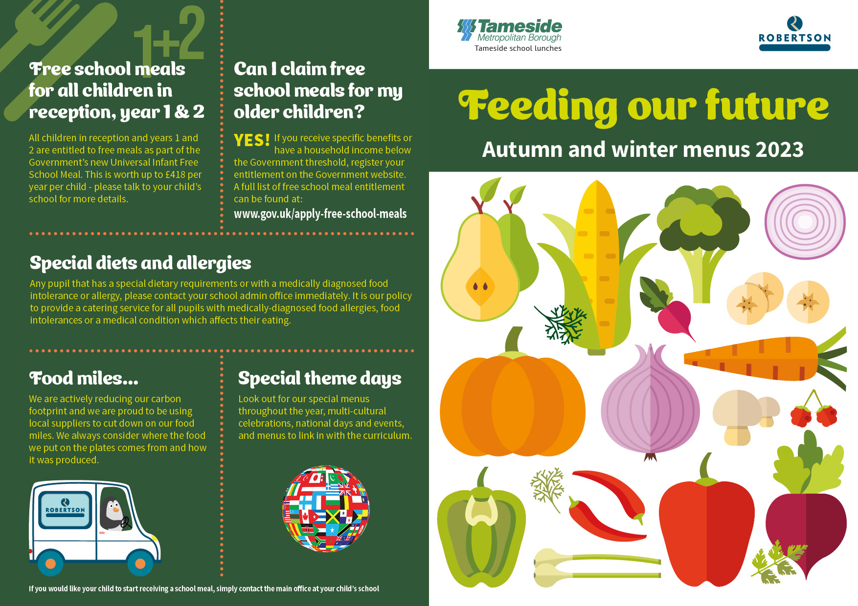

Meatballs in gravy  Vegetarian sausages  Sandwich of the day  Jacket potato with choice of filling  Rice pudding with sultanas  Fresh fruit, yogurt  Creamed potatoes, pasta, cabbage, carrots | Katsu chicken curry  Cheese whirl  Sandwich of the day  Jacket potato with choice of filling  Ice cream tub  Fresh fruit, yogurt, cheese and biscuits  Boiled rice, creamed potatoes, baked beans and sweetcorn | Roast chicken and gravy  Quorn bolognaise  Sandwich of the day  Jacket potato with choice of filling  Fruit sponge and custard  Fresh fruit, yogurt  Baked new potatoes, pasta, broccoli and carrots. | Homemade meat pie  Pizza choice  Sandwich of the day  Jacket potato with choice of filling  Shortbread biscuit with orange wedge  Fresh fruit, yogurt, cheese and biscuits  Creamed potatoes, ½ baked jacket, sweetcorn, green beans | Fish Friday  Quorn dippers with BBQ sauce  Sandwich of the day  Jacket potato with choice of filling  Fruit muffin  Fresh fruit, yogurt  Chips, pasta, mushy peas, baked beans
Sausages with Gravy  Quorn curry  Sandwich of the day  Jacket potato with choice of filling  Ice cream  Fresh fruit, yogurt, cheese and biscuits  Savoury rice, ½ jacket, peas, carrots | Breaded chicken fillet  Mediterranean pasta bake  Sandwich of the day  Jacket potato with choice of filling  Raspberry bun  Fresh fruit, yogurt  Creamed potato, jacket wedges, sweetcorn, green beans | Roast Turkey, stuffing and gravy  Veggie meatballs  Sandwich of the day  Jacket potato with choice of filling  Syrup sponge and custard  Fresh fruit, yogurt  New potatoes, creamed potatoes, spring cabbage and sweetcorn | Spaghetti bolognaise  Homemade cheese flan  Sandwich of the day  Jacket potato with choice of filling  Fruit jelly  Fresh fruit, yogurt, cheese and biscuits  Creamed potatoes, ½ jacket potato, broccoli, baked beans | Fish Friday  Omelette  Sandwich of the day  Jacket potato with choice of filling  Homemade biscuit with a slice of fruit  Fresh fruit, yogurt  Chips, new potatoes, garden peas, beans
Chilli and nachos  Cheese and tomato pizza  Sandwich of the day  Jacket potato with choice of filling  Angel delight  Fresh fruit, yogurt, cheese and biscuits  Savoury rice, diced herby potatoes, sweetcorn and peas | Turkey burger in a bun  BBQ glazed veggie sausage  Sandwich of the day  Jacket potato with choice of filling  Jelly and fruit  Fresh fruit, yogurt  Half jacket potato, boiled rice, carrots, baked beans | Roast beef with gravy and Yorkshire pudding  Quorn sausage  Sandwich of the day  Jacket potato with choice of filling  Chocolate sponge and custard  Fresh fruit, yogurt  New potatoes, mashed potatoes, cauliflower florets, carrots | Chicken Tikka  Cheese whirl  Sandwich of the day  Jacket potato with choice of filling  Fruity flapjack  Fresh fruit, cheese and biscuits, yogurt  Boiled rice, creamed potatoes, baked beans, sweetcorn | Fish Friday  Vegetarian sausage roll  Sandwich of the day  Jacket potato with choice of filling  Arctic roll  Fresh fruit, yogurt  Chips, pasta, mushy peas, baked beans
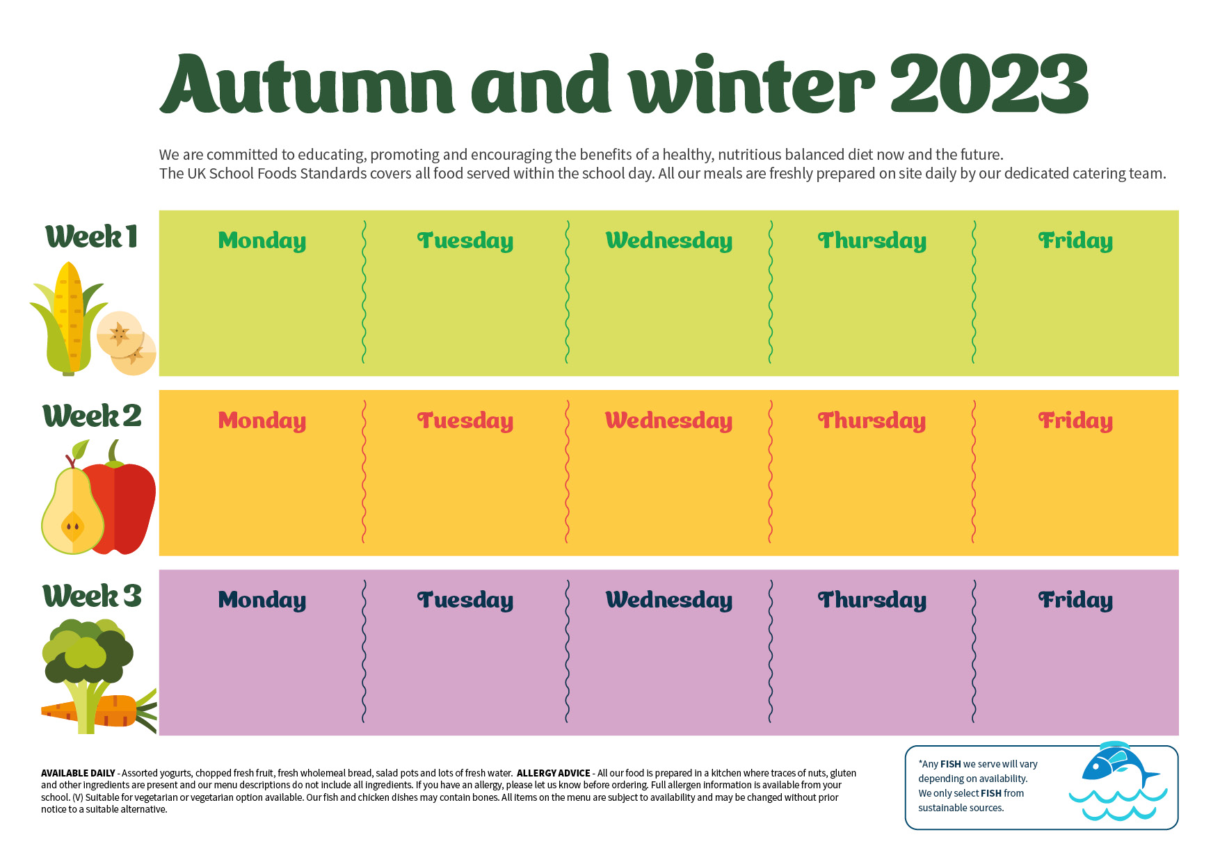
ra

